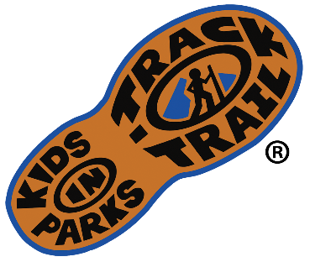
For Immediate Release

Media Contact:
Jason Urroz
Program Director, Kids in Parks
Blue Ridge Parkway Foundation
(866) 308-2773, ext. 384
jurroz@brpfoundation.org
www.kidsinparks.com

Kids in Parks – A national initiative for getting children outdoors
Since 2009, Kids in Parks has encouraged kids and families to get outdoors and engage with nature via their principal initiative, TRACK Trails. With over 200 family-friendly locations across 15 states, Washington D.C., and the Qualla Boundary, Kids in Parks utilizes trails for hiking, biking, geocaching, paddling, and disc golf. Self-guided brochures at each site help turn regular outings into explorative outdoor experiences. While hiking, kids can learn about natural, cultural, or historical resources in a region. Registered hikers at KidsinParks.com can become official "Trail TRACKers" and earn free prizes designed to encourage future outings.

“The network of TRACK Trails we have formed in parks and other outdoor agencies gives kids and families more options to get outdoors. To get ‘unplugged’ and get connected to the resources and special places that make public lands so wonderful,” says Jason Urroz, director of Kids in Parks.

Kids in Parks began in 2009 on the Blue Ridge Parkway, developed by the Blue Ridge Parkway Foundation in partnership with the National Park Service and the Blue Cross Blue Shield of North Carolina Foundation. As the program demonstrated easy implementation and effectiveness in getting children outdoors, Kids in Parks rapidly expanded to other parks and public lands across the country. Achievements of the program include endorsement by the American Academy of Pediatrics, awarded as a Let’s Move! Champion of Change by the White House, and acknowledgment for Outstanding Public Engagement by the Public Lands Alliance. Kid in Parks is also reviewed favorably as a practice-tested intervention by the Center for Training and Research Translation and operates a complementary parks prescription initiative, TRACK Rx, working with over 600 pediatric partners.

"As both a park manager and parent, I appreciate that Kids in Parks is an effective way to connect families to parks without a lot of extra staff expense,” says Sean Higgins, Interpretation and Education Program Manager for North Carolina State Parks. “The network of TRACK Trails encourages kids to explore the resources of parks and helps them develop an appreciation for natural spaces. Ultimately, both families and parks benefit from the program."

As of August 2021, Kids in Parks had received one-million adventure registrations from kids, with 2-million overall participants when factoring in additional family members. Despite COVID-19, the program continues to meet its mission. The majority of participants in the last years have been first-time visitors to the various partnered parks, and over half of the kids were intentionally visiting for the TRACK Trail.

There was also a significant rise in the popularity of Kids in Parks' latest initiative, e-Adventures. To increase accessibility during the COVID-19 pandemic, Kids in Park launched e-Adventures to help families stay healthy and connected to nature while at home. These virtual activities are curated from the more popular TRACK Trail activities and re-designed for smartphones or other browser-compatible devices with interactive nature guides, STEM projects, and wellness exercises. You can complete e-Adventures in your backyard, neighborhood, local park, an official TRACK Trail, or anywhere in between.

"We have truly enjoyed this program, and the kids have learned so much this summer," says Liz DeLise, a Trail TRACKer parent. "Just last night, as we were coming back from Hanging Rock State Park, a neighborhood kid commented to Sophia that we are always gone. Sophia proudly responded that 'we go on big adventures!'"
To learn more about TRACK Trails near you, or explore e-Adventures from your phone or tablet, visit KidsinParks.com. Kids in Parks can also be followed on Facebook and Instagram.

