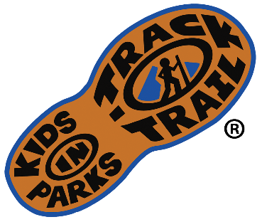
For Immediate Release

Media Contact:
Jason Urroz
Program Director, Kids in Parks
Blue Ridge Parkway Foundation
(866) 308-2773, ext. 384
jurroz@brpfoundation.org
www.kidsinparks.com

Free Virtual Nature Activities from Kids in Parks to complete at [Name of TRACK Trail(s)]
For over a decade, Kids in Parks has connected kids and families to public lands nationwide through their principal initiative, TRACK Trails. With family-friendly trails for hiking, biking, canoeing, disc golf, and more, over 200 locations exist in the TRACK Trail network, spanning 15 states, Washington, D.C., and the Qualla Boundary. Each TRACK Trail hosts a series of self-guided activity brochures that turn hikes into exciting outdoor experiences. Participants can learn about the natural, cultural, or historical resources of a region while exploring.

In 2020, to increase accessibility during the COVID-19 pandemic, Kids in Park launched e-Adventures to help families stay healthy and connected to nature while at home. These virtual activities are curated from the more popular TRACK Trail activities and re-designed for smartphones or other browser-compatible devices. The e-Adventures initiative was a hit and has since expanded to include more interactive nature guides, STEM projects, and wellness exercises. You can complete e-Adventures in your backyard, neighborhood, local park, an official TRACK Trail, or anywhere in between.
Children benefit from spending time in nature with increases in overall wellness. Likewise, parks benefit when people use them. Finding ways to create stronger connections between children and parks cultivates stewards who understand the importance of nature and the benefit of public lands. To encourage future outings, Kids in Parks mails prizes to registered "Trail TRACKers." The first completed activity unlocks the Trail TRACKer Passport with a collectible sticker and the first Adventure Card. The Adventure Cards are portable, waterproof nature guides with 15 topics to earn through completion in the program.
To begin exploring e-Adventures today, go to KidsInParks.com/e-Adventures. Choose an activity to complete and register your e-Adventure the same way you would any other Kids in Parks adventure.

Kids in Parks began on the Blue Ridge Parkway, developed by the Blue Ridge Parkway Foundation in partnership with the National Park Service and the Blue Cross Blue Shield of North Carolina Foundation. As the program demonstrated easy implementation and effectiveness in getting children outdoors, Kids in Parks rapidly expanded to other parks and public lands across the country. [including trails at "insert nearby TRACK Trails in region."]
To learn more about e-Adventures and the TRACK Trails initiative, go to KidsinParks.com.

