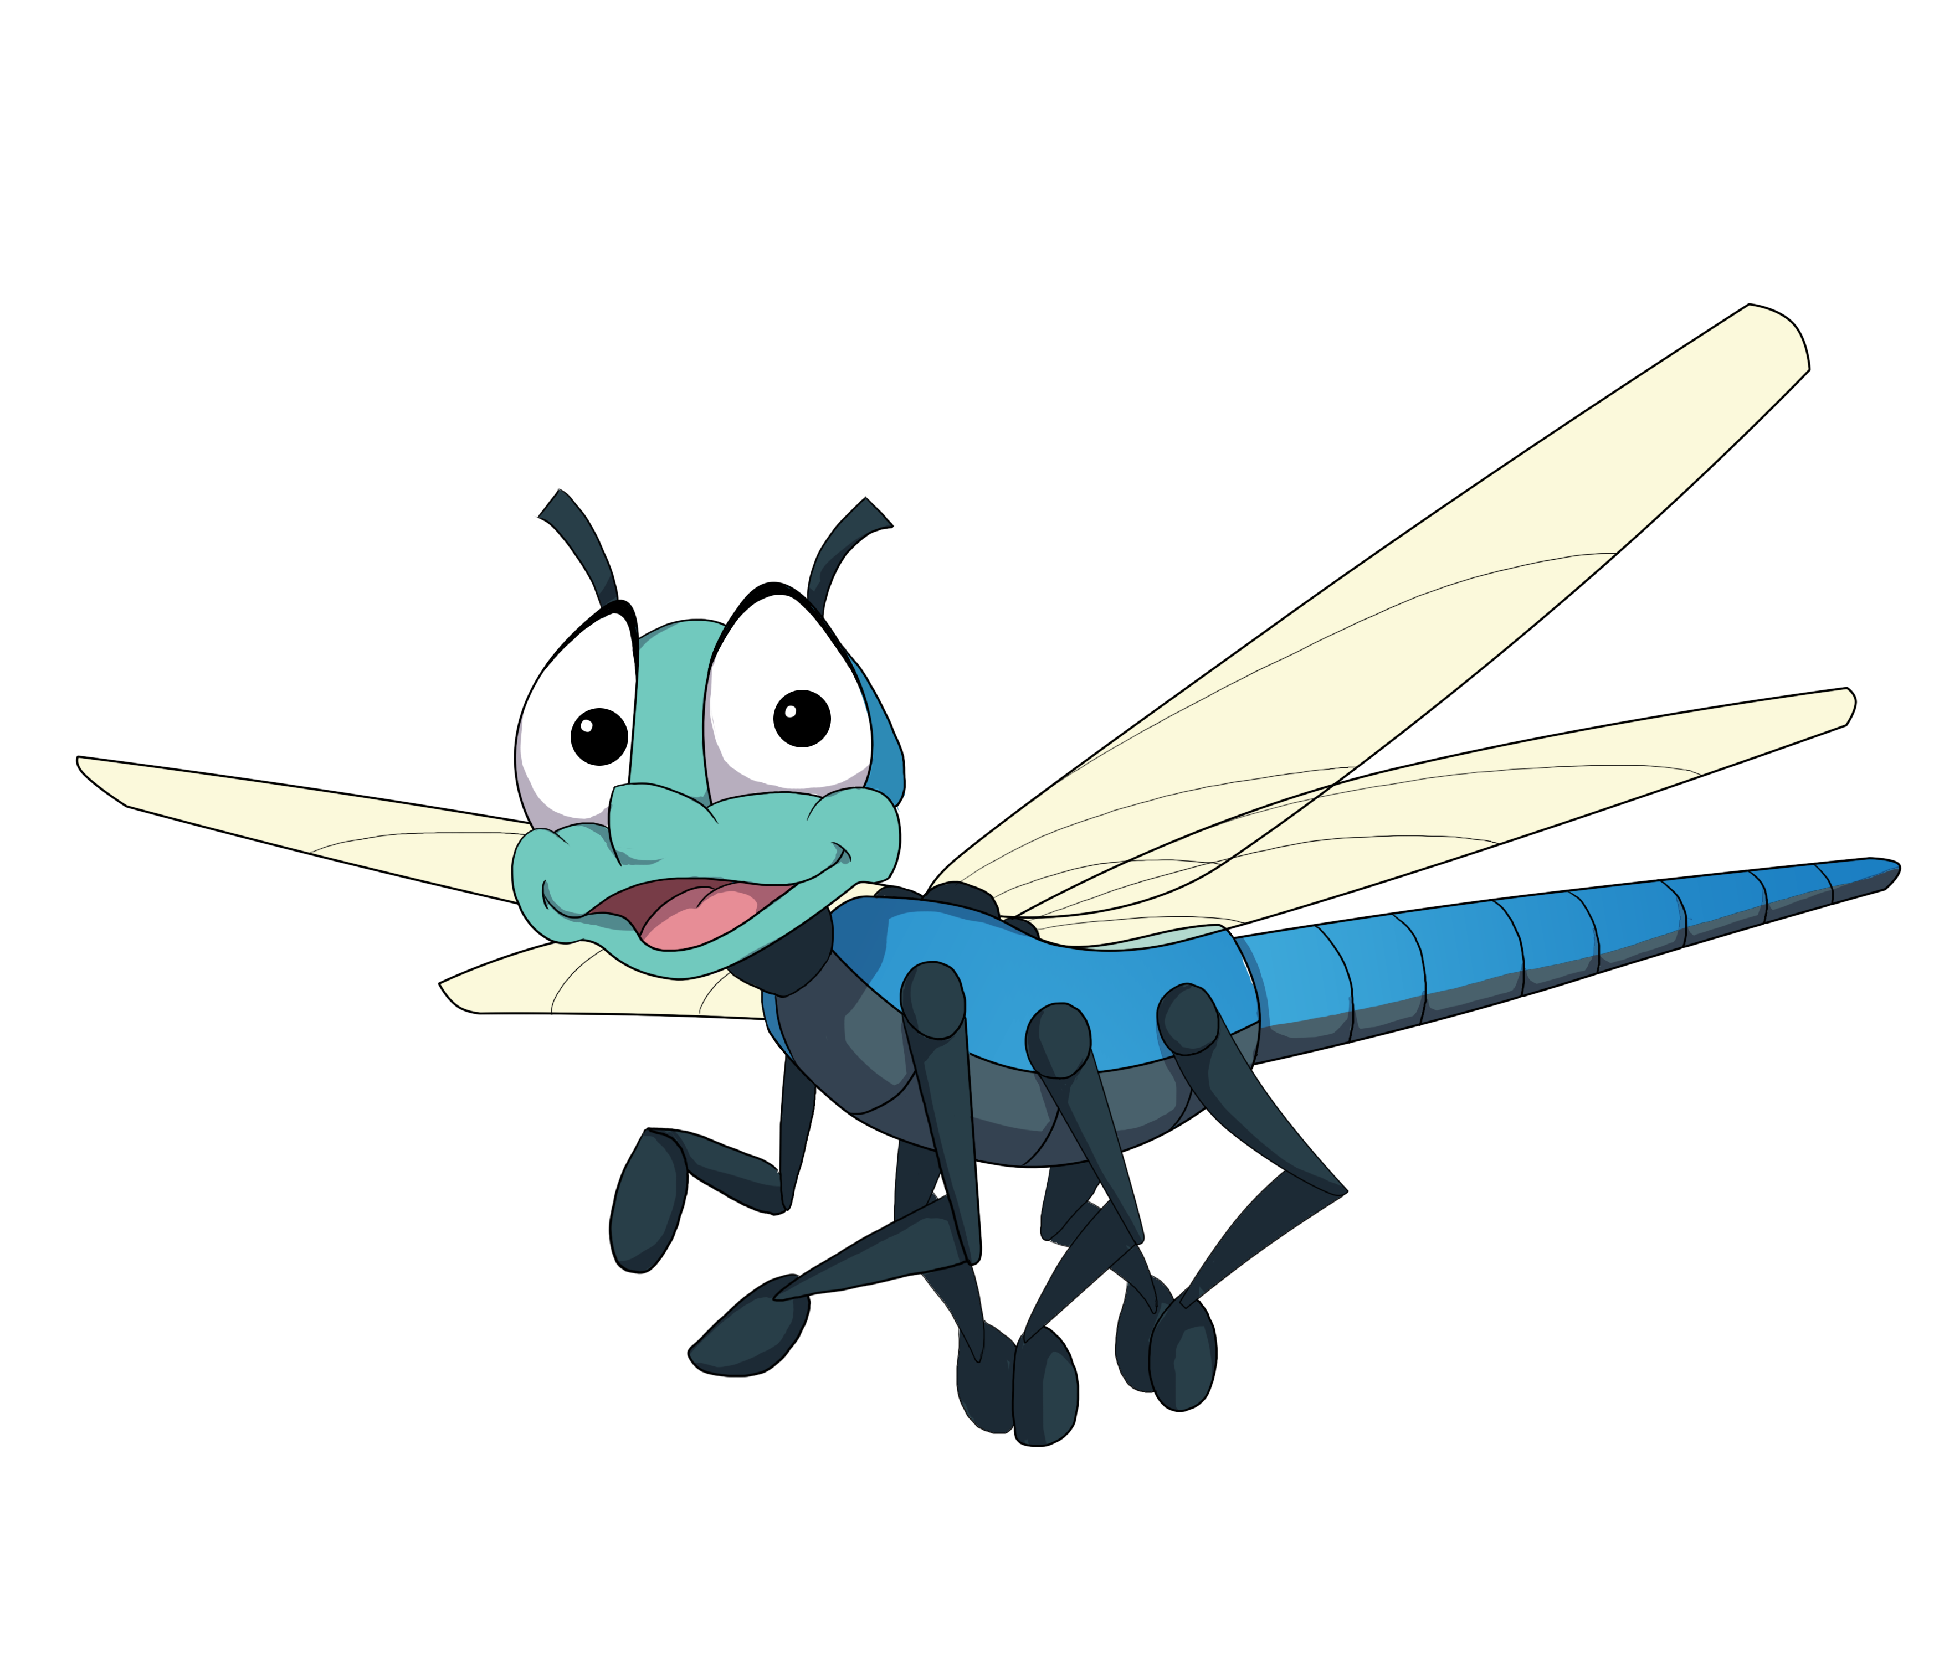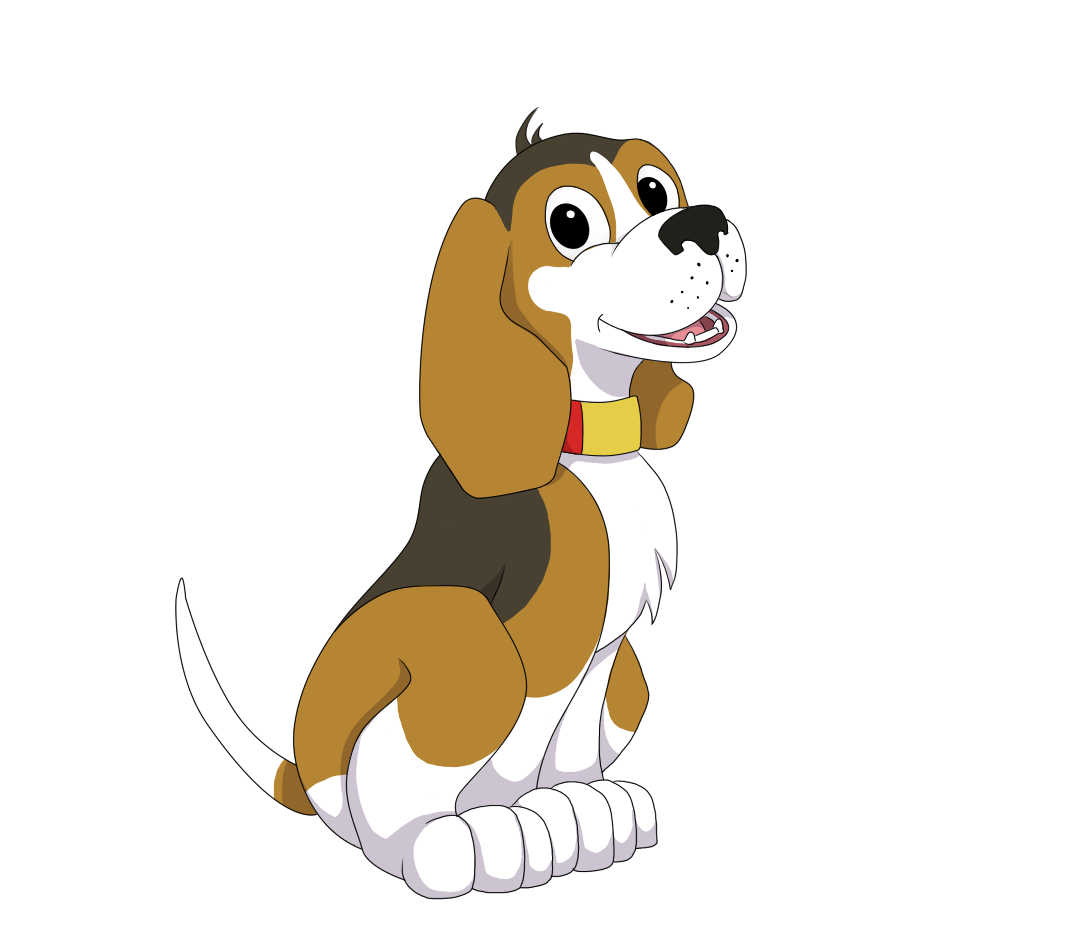

Join us! With [insert any other collaborating partners… and] Kids in Park to celebrate the opening of a new TRACK Trail! Event begins at:

00:00 PM

[Give details of event: Ex. “There will be a ribbon cutting with a guided hike to follow.”]

**PARK NAME, TRAIL NAME OR OTHER LOCATION**

STREET ADDRESS, CITY, STATE, ZIP

[Any other direction (driving, parking, location inside park, etc.]

MONTH 00, 2020

